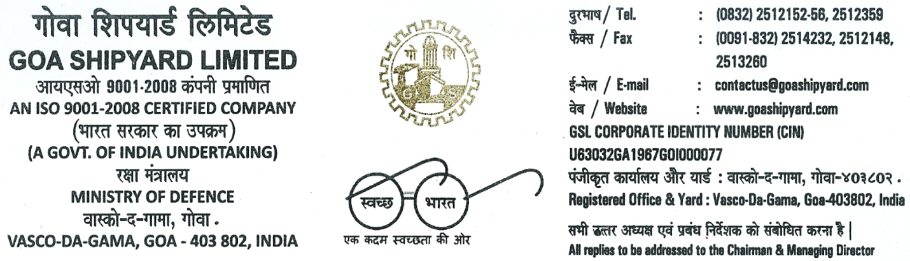
CRISIL CREDIT RATING
Long – Term “AAA”
Short – Term “A1+”

Ref No: GSL/03/IDT/GST

Registration Details under Goods and Services Tax (GST)

As you are aware that, India is migrating to GST regime, with likely implementation of Goods and Services Tax effective from 01.07.2017 replacing various existing Indirect Tax Laws.
.
2. Under GST regime, Supply of Goods and Services, Tax Payment, Input Tax Credit, Returns, Reports and Refund etc. will be administered and controlled online by GST Department through GSTN (GST Network).GST Registration Number (GSTIN) is very important for transactions under GST regime. It is important to mention correct GST Registration Number against all transactions for supply of Goods and Services. It will be mandatory for all registered dealers to adopt GST compliant invoice in the prescribed format.

3. GST Registration No. of GSL and details of person to be contacted in case of any query or information are given below for updating the master records of GSL Vendors and Suppliers. (Copy of communication about GST Registration No. enclosed)

Name of the Organization - GOA SHIPYARD LIMITED
State - GOA
State Code - 30
GST Migrated Registration No. - 30AAACG7569F1ZR
Contact Person Details - Sanoj Kumar Pandey (Manager-Finance)
Mobile /Tel No. - 9008839019/0832 2512152
Email - sanojpandey@goashipyard.com

4. For a smooth transition to the GST regime, you are requested to provide state wise GST Registration No. of your organization and details of person to be contacted in case of any query or information at the earliest in the attached format so as to update our records.

Note:
The 15 digit Provisional or Migrated GST Registration No. is the GST user ID shared by Commercial tax or Service tax or Central Excise authorities that begin with 2 digit number (comprising the state code) 10 digit of PAN and 3 check digits at the end. Please ensure that Vendors and Suppliers share the correct GST Registration number.

You are requested to provide your GST Registration number and contact details of the person responsible for GST to communicate in case of any query or information in the format prescribed as below as per Annexure XX duly signed & stamped in firm’s letter head.

Thanking you,
Yours faithfully,
For Goa Shipyard Limited

Annexure XX

1. Name of the Organization: _________________________________________________________

2. State : _________________________________________________________

3. State Code : _________________________________________________________

4. GST Registration No : __________________________________________________________

5. Type of Entity
(Company/Firm/LLP/SEZ):___________________________________________________________

6. Name of Contact Person: ___________________________________________________________

7. E-mail id : ___________________________________________________________

8. Telephone No. :___________________________________________________________

9. Mobile No : ____________________________________________________________

Please send a copy of the GST Registration certificate or email received from GST Department confirming migration from current registration to GST registration.

Date……………………. Signature………………………….
Place…………………… Name……………………………....
Designation……………………….
Seal…………………………………

